Sacred Heart Parish Festival 2024
Quilt Raffle Tickets

Don’t miss out on your opportunity to take home one of these two handmade quilts!

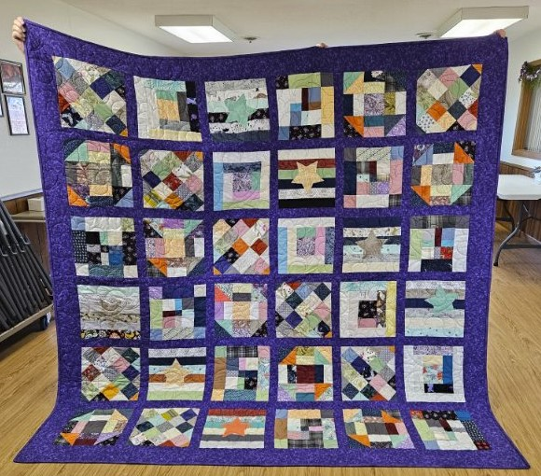
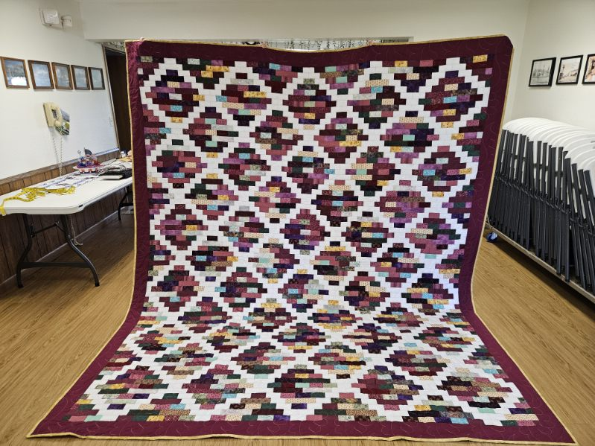

Quilting the Psalms
82 X 88

Alice’s Garden
96 X 114

$5 chances to win one of these two quilts are now available!
These quilts will be raffled off at the Freeport Festival on Sunday July 21st.
Tickets available now at the parish house and in the Quilts and More stand the day of the event.
Thank you in advance for your purchase in support of the Sacred Heart Parish.

